ADVENTURE WORKS · TECHNICAL SUPPORT

Bottom Bracket or Crank Play and Creaking
Drivetrain Document TS-014 Rev. A
Applies to | All Adventure Works models
Difficulty | Advanced
Time required | 30 – 75 minutes
Tools needed | BB tool (model-specific), Crank tools / hex keys, Torque wrench, Grease / anti-seize / retaining compound

Symptoms
- Side-to-side play felt by rocking the crank arms.
- A deep creak under hard pedaling, often when standing.
- Grinding or roughness when turning the cranks by hand.
- A knock that tracks with pedal position, not wheel position.
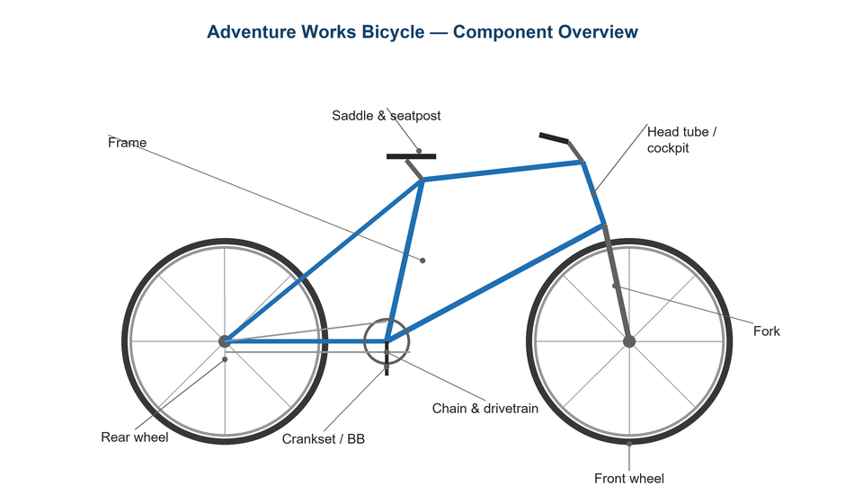
Figure 1. The bottom bracket carries the crank axle at the center of the frame.

Likely Causes
- Loose crank preload or pinch bolts.
- Worn or dry bottom bracket bearings.
- A press-fit BB that has loosened in the shell.
- Contaminated or dry crank/BB interface.
- Incorrect spacers causing bearing bind or play.
Safety first
- Use the correct BB tool for your standard to avoid rounding the cups.
- Follow the maker's torque and assembly compound guidance, especially for press-fit.
- Recheck crank preload and pinch-bolt torque after the first ride.

Customer Fix — Step by Step
Suitable for home repair with basic tools. Work through the steps in order.
- Rock the crank arms side to side to feel for play, and spin them to feel for roughness.
- On a two-piece crank, snug the preload cap until play disappears, then torque the arm pinch bolts to spec.
- Confirm the issue isn't actually the pedals or chainring bolts (check those first — they're easier).
- If there's roughness or persistent creak, the bearings likely need service (technician step).
- Keep the BB area clean; avoid blasting it with a pressure washer.
- Re-test for play and noise after tightening.

Technician Reference
Additional checks and adjustments for service technicians and advanced users.
- Remove the crank and BB; identify the standard (threaded BSA/Italian vs press-fit BB30/PF30/BB86, etc.).
- Inspect bearings for play, notchiness, or rust; replace worn bearings/cartridges.
- Clean shell and threads/bores; apply grease or anti-seize on threaded BBs, or the specified retaining compound on press-fit.
- Install with the correct spacers and preload so bearings spin free without play.
- Torque threaded cups to spec; for press-fit, press squarely and check for a creak-free fit (consider a thread-together BB if creaks persist).

Torque & Specifications
Fastener / setting | Specification
Threaded BB cups | 35 – 50 N·m
Crank preload cap | Snug, ~0.5 – 2 N·m
Crank arm pinch bolts | 12 – 14 N·m
Bearing play | None permitted
Press-fit | Use specified compound
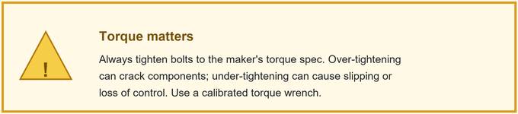
Figure 2. Preload first, then torque the pinch bolts; respect press-fit procedures.
Pro tips
- Persistent press-fit creak? A thread-together BB often solves it permanently.
- Always set crank preload before tightening the pinch bolts.

When to Visit a Service Center
- A press-fit BB needs press/extraction tools you don't have.
- The BB shell or frame threads are damaged.
- Creaking continues after a full BB service.
- You're unsure which BB standard your frame uses.
This guide is provided for reference. Torque values are typical starting points — always follow the specific component manufacturer's instructions. © Adventure Works.

